**MABUHAY, INC.**

**CULTURE SCHOOL**

**(Established 1990)**



**PROGRAM INFORMATION**

**School Year 2016-2017**

**Saturdays,**

**starting October 15, 2016**

**to May 20, 2017**

**Time: 1:00 to 3:00 pm**

**College Park Community Center**

**5051 Pierce Avenue**

**College Park, MD 20740**

**MABUHAY, INC.**

**(A Filipino American Association)**

[**www.mabuhayinc-md.org**](http://www.mabuhayinc-md.org)

**What is the Mabuhay, Inc. Culture School (MICS)?**

**MICS** is a weekend cultural and educational enrichment program for ***all*** children ages 4 – 16. Through its activities, MICS promotes Mabuhay, Inc.’s overall mission of **Harmony in Diversity**.

MCj03975280000[1]

**What are the objectives of MICS?**

MCj04359890000[1]MICS is designed to teach the common bonds of history, geography and culture between the United States and the Philippines. It aims to enhance the self-esteem and cultural competence of young people by learning and sharing the language, customs, and traditions of the Philippines.

**How did MICS come about?**

MCj03981630000[1]MICS was started in 1990 by a group of parents led by Mencie Y. Hairston who saw the need for their growing children to maintain their Filipino traditions and values while adapting to life in the United States..

**MICS is FUN!**

● We learn while we play! Our teachers and volunteers make learning fun with hands-on activities in arts and crafts, music, folk dancing, literature, history and conversational *Filipino*.

● Your child will form friendships with children who share similar life experiences and meet adults who successfully navigate our multicultural and multi-ethnic society.

● Performance opportunities build self confidence.

● Older students may fulfill their school volunteer hours requirement at Culture School.

**What is the cost of attending MICS?**

**j0222015**Attendance is free to Mabuhay, Inc. members. Non-Mabuhay Inc. members pay a nominal fee to cover materials and program expenses.

MCj03342680000[1]**How can parents help?**

Cultural education is a partnership between parents and teachers. We ask that you bring and pick up your child on time every Saturday. We also encourage that you reinforce your child’s learning by continuing the dialogue at home. You may also be asked to bring ***merienda***, assist in class or chaperone scheduled field trips.

**For further questions**, contact:

**Moks Laureles**:fmflii@gmail.com

Phone: (202) 957-1620

**Austin Conaty:** [austin.conaty@gmail.com](mailto:austin.conaty@gmail.com)

Phone: (301) 614-6149

**Liezl Argente:** [liezlargente@gmail.com](mailto:liezlargente@gmail.com)

Phone (301) 885-9683

**Mencie Hairston:** [mencie.hairston@gmail.com](mailto:mencie.hairston@gmail.com)

Phone: (240) 355-4930

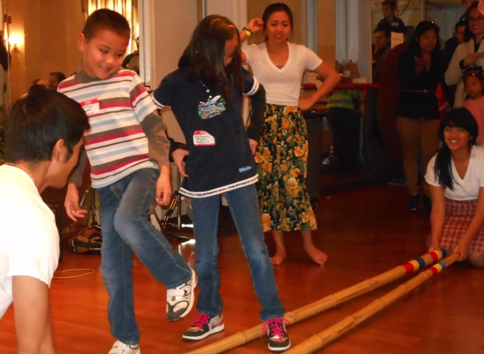

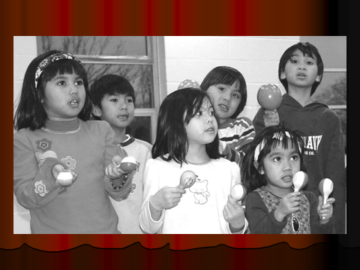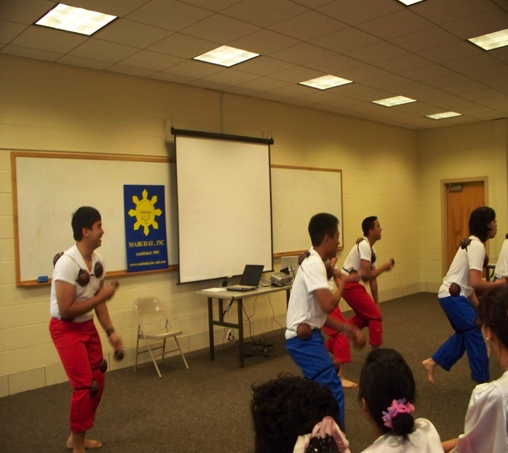

“Maglalatik” Dance

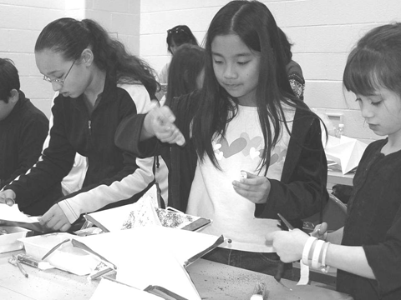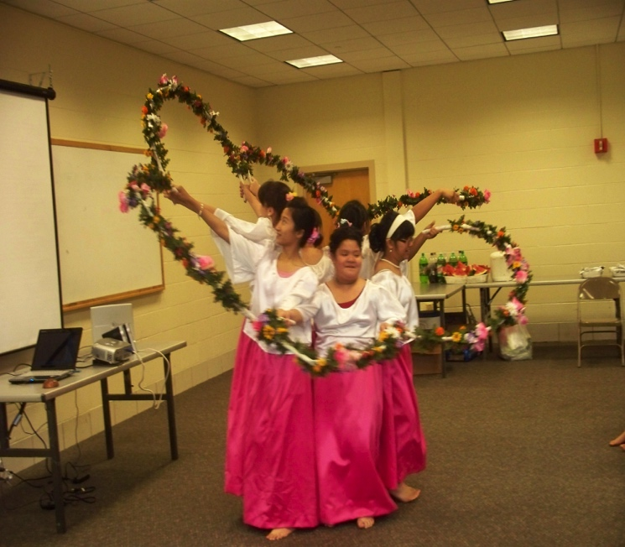

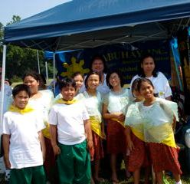

“Bulaklakan” Dance



[Type a quote from the document or the summary of an interesting point. You can position the text box anywhere in the document. Use the Text Box Tools tab to change the formatting of the pull quote text box.]